Following steps to show how to use Clave 2 with ASP.NET to realize the authentication of user.
- Please open SDK/Clave2 Basic/Authentication/Tools to install "LCAUTHInstall"
- Open the SDK/Clave2 Basic/Authentication/Samples , you can get the "LCWebInit" and open it as figure 1,
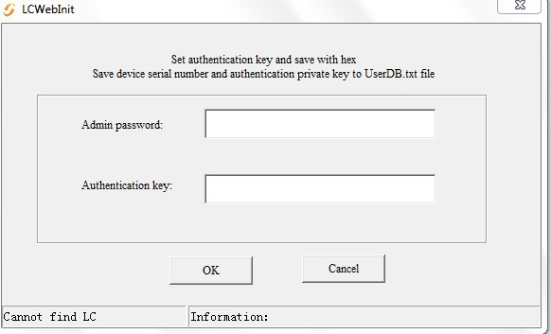
- Fill the Admin password and Authentication key, click OK to get the UserDB.txt. And copy the UserDB.txt under "Demo_asp.net".
- Please note you should add the write-read permissions to UserDB.txt( right the UserDB.txt, click Properties---Security---Advanced--Change Permissions---Add---input everyone, click ok to finish it)
- Build the web serve.
- Please plug in the LC dongle on your user computer, and input the server web address in your browser.
- Open the "logon.aspx ", you can find it under the "Demo_asp.net".
- Input the Authentication key and the device ID which you could get from UserDB.txt.
End.

